For full rang of fittings and current prices please refer to online shop BoatStuffNZ

SAINT” NYLON CANOPY FITTINGS
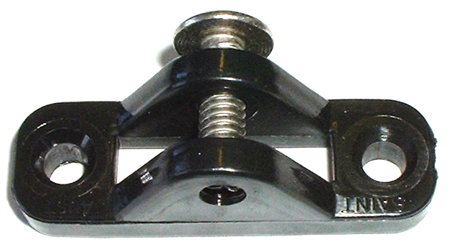
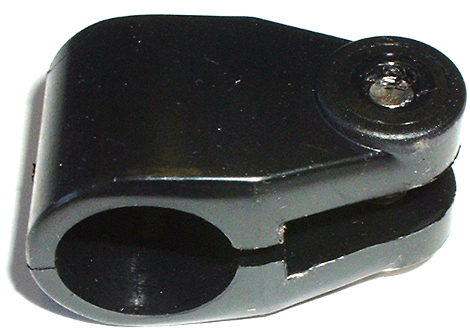
SRP
$2.10 +GST
SRP
$3.40+GST
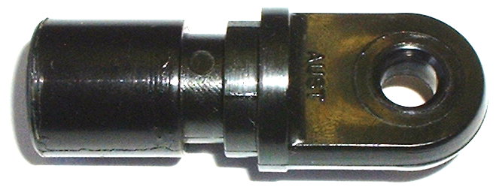

SRP= $3.30 +GST

Deck Mount (with screw) ¾” Bow End Insert ¾” Bow Knuckle ¾”
Black Code#580202 Black Code#580204 Black Code#580206
White Code#580203 White Code#580205 White Code#580207

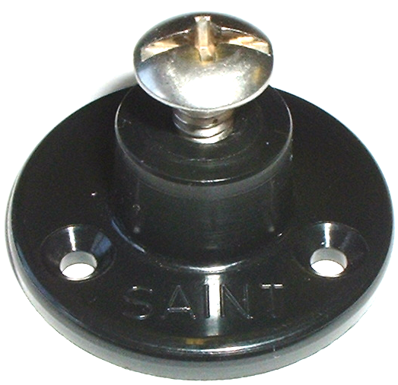
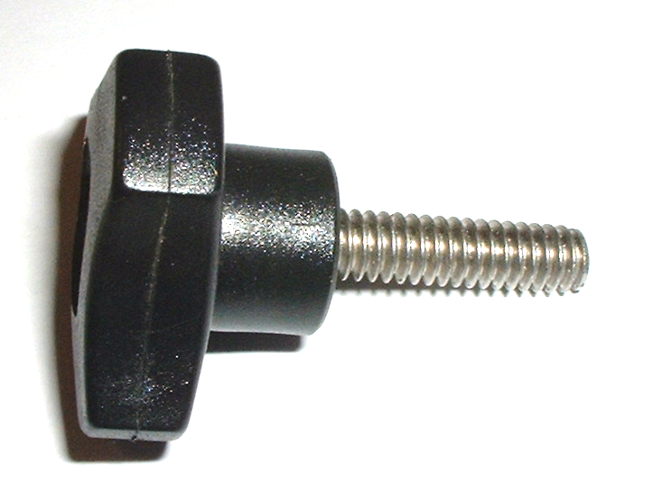
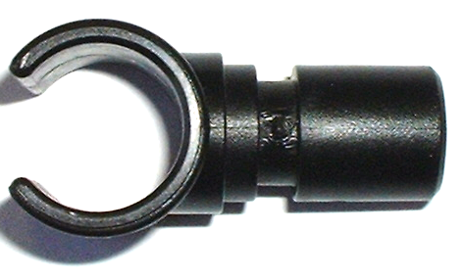

SRP $1.15+GST

SRP $4.50+GST
Plain SS screws
$1.00+GST

SRP $4.50+GST

“C” Clamp ¾” Side Mount Thumb Screw
Black Code#580220 Black Code#580260 Black Code#580240
White Code# 58222 White Code#580262 White Code#580242

